**REAL TIME EMOTION DETECTION USING OPENCV WITH CONTENT RECOMMENDATION**

**SUBMITTED BY:**

AMAL J A

S3 MCA

ROLLNO. : 06

**CHAPTER 1**

**INTRODUCTION**

* 1. **GENERAL INTRODUCTION**

In today's technology-driven world, the ability to understand and respond to human emotions is gaining significant importance. Emotion-aware applications have the potential to revolutionize various industries, from entertainment to healthcare. Our project, "Real-Time Emotion Detection for Enhanced User Experiences," is a significant step in this direction. The aim of this project is to develop a real-time emotion detection system that can recognize and respond to human emotions through facial expression analysis. By leveraging the power of computer vision and deep learning techniques, our project seeks to detect emotions such as happiness, sadness, anger, and more in real-time. Emotion recognition technology is rapidly evolving, and it plays a pivotal role in making our interactions with computers and devices more empathetic and responsive. Our project, "Real-Time Emotion Detection using OpenCV" is a comprehensive exploration of this cutting-edge technology and its practical applications. Understanding human emotions in real-time is crucial for creating human-centric digital experiences. This technology has far-reaching implications, from improving mental health and well-being to offering personalized content recommendations and humanizing AI interactions. The ability to detect emotions enables systems to be more responsive and empathetic, leading to richer and more meaningful user interactions.

* 1. **GOAL OF THE PROJECT**

The goal of your project, "Real-Time Emotion Detection using OpenCV with Text Recommendation," is to develop a comprehensive and responsive system that seamlessly integrates emotion recognition and text recommendation based on real-time facial expressions. This project aims to accomplish the following key objectives:

1. **Facial Emotion Recognition:** Implement a sophisticated real-time emotion detection system that can accurately analyse facial expressions and identify a range of human emotions, including joy, sadness, anger, surprise, and more.
2. **Real-Time Responsiveness:** Enable the system to provide dynamic and instantaneous feedback by processing video streams in real time. The goal is to ensure that it responds rapidly to the user's changing emotional states.
3. **Text Content Recommendations:** Incorporate natural language processing (NLP) techniques to recommend text content that is contextually relevant to the user's detected emotional state. The recommendations can include articles, quotes, affirmations, or any form of text content that aligns with the user's emotions.
4. **Enhanced User Experience:** Create an enhanced user experience across various domains, including well-being support, digital content consumption, and interactive assistance. By delivering empathetic and contextually relevant text recommendations, the system aims to make user interactions more meaningful and personalized.
5. **Emotion Analysis Accuracy:** Strive for high accuracy in recognizing a broad spectrum of emotions, ensuring that even subtle emotional cues are captured. Continuous improvement in emotion classification is essential.
6. **Real-World Applicability:** Aim to make the system applicable to various real-world scenarios, such as online education, video conferencing, and customer service, where understanding emotional states can enhance interactions.
7. **Personalization:** Implement algorithms that adapt recommendations to individual user preferences and emotions, providing a tailored experience that resonates with each user's unique needs.
8. **Privacy and Security:** Ensure that the project follows ethical guidelines and respects user privacy. Sensory data, such as video feeds, should be handled with care, and data security measures should be in place.

**CHAPTER 2**

**LITERATURE SURVEY**

* 1. **STUDY OF SIMILAR WORK**

There have been a number of studies on the use of machine learning for real time emotion recognition. They primarily rely on recognizing the emotions only and the accuracy of the emotion detection is not much maintained.

* + 1. **EXISTING SYSTEM**

Many existing emotion detection systems, particularly those based on facial recognition, can be sensitive to environmental factors, such as lighting conditions and the subject's facial expressions. This can result in inaccurate readings and reduced reliability, potentially leading to incorrect content recommendations.

* + 1. **DRAWBACKS OF EXISTING SYSTEM**
  1. **Data Privacy and Security:** Collecting and storing user data, especially facial images, raises concerns about data privacy and security. Ensuring the safe handling of user data is critical.
  2. **Accuracy and Reliability**: Many existing systems struggle with accurate and reliable real-time emotion detection. Environmental factors, lighting conditions, and diverse facial expressions can impact the precision of emotion recognition.
  3. **Limited Emotional Range:** Some systems are better at recognizing basic emotions like happiness, sadness, and anger, while more complex or subtle emotional states might be overlooked.
  4. **Privacy Concerns:** Continuous monitoring of users' facial expressions and text input can raise privacy concerns. Users may be uncomfortable with such extensive data collection.
  5. **Lack of Context:** Existing systems may not consider the context of emotions. For example, an expression of anger during a movie might be unrelated to the user's actual mood.
  6. **Content Recommendations:** Content recommendation engines often rely on straightforward rules, lacking the ability to understand nuances in users' emotional states.
  7. **Cultural and Individual Variations:** Emotional expression can vary greatly among individuals and across cultures. Existing models may not account for these differences.
  8. **Latency:** Real-time processing can introduce latency, affecting the user experience, especially in applications that demand instant feedback.
  9. **Content Diversity:** Existing systems may have limitations in diversifying content recommendations. They might prioritize popular content over unique or niche options.
  10. **Adaptation and Learning:** Some systems lack the ability to adapt and learn from user interactions over time, leading to static recommendations.

**CHAPTER 3**

**OVERALL DESCRIPTION**

* 1. **PROPOSED SYSTEM**

The proposed system, "Real-Time Emotion Detection with Text-Based Content Recommendation," aims to provide a comprehensive solution that combines real-time emotion detection from facial expressions with intelligent content recommendation based on users' emotional states expressed in text. This system leverages cutting-edge technologies such as computer vision, natural language processing (NLP), and machine learning to enhance user experiences in various applications. The System we proposed is facial emotion using CNN Algorithm. The goal is to develop a system that uses a camera to identify a person's emotions. The goal is to process every frame of a video via a deep learning convolution neural network model that has been trained to categorize video frames into accident- or non-accident-related categories. Convolutional Neural Networks have shown to be a quick and reliable method for classifying photos. In comparison to previous image classification methods, CNN-based image classifiers have achieved accuracy levels of over 95% for relatively smaller datasets. They also require less preparation. Computer vision tasks like object recognition and image categorization frequently employ CNNs, a kind of deep learning algorithm. CNNs are trained on a sizable dataset of labelled faces for facial recognition in order to learn the distinctive features and traits of various faces, such as the placement of the eyes, nose, and mouth. When a fresh face is introduced to the system, CNN examines the facial traits and creates a distinctive image of the face known as a face embedding.

* 1. **FEATURES OF PROPOSED SYSTEM**

The proposed system, "Real-Time Emotion Detection with Text-Based Content Recommendation," encompasses several key features designed to provide a comprehensive and user-centric experience. Here are the prominent features of the system:

1. **Real-Time Emotion Detection:** The system employs computer vision techniques to perform real-time emotion detection from users' facial expressions. It recognizes a wide range of emotions, including happiness, sadness, anger, surprise, and more. Emotion detection continuously monitors users' facial expressions through their device's camera.
2. **Text-Based Emotion Analysis:** In addition to facial analysis, the system integrates natural language processing (NLP) to analyse text-based inputs, such as chat messages, social media posts, or other textual data. The NLP component extracts emotional context and sentiment from the text, adding to the understanding of users' emotional states.
3. **Emotion-Content Mapping:** The system maps detected emotions to a predefined emotional content taxonomy. For example, it associates emotions like "happiness" with content related to positive news, comedy, or uplifting music, and "anger" with recommendations related to anger management or relaxation methods. The mapping is dynamic and adaptable, allowing for personalized content recommendations.
4. **Content Recommendation Engine:** Based on the detected emotions and emotional context from both facial expressions and text inputs, the system provides content recommendations tailored to users' emotional states. The recommendation engine uses collaborative filtering, content-based filtering, and machine learning algorithms to suggest diverse and personalized content, such as articles, videos, music, movies, or social media posts.
5. **User Privacy and Control:** Users have the option to enable or disable real-time emotion detection and text analysis, prioritizing their privacy. They can set preferences for the types of content they'd like to see during specific emotional states and provide feedback to refine recommendations.
6. **Adaptive Personalization:** Over time, the system adapts to users' preferences and emotional expressions through machine learning. Recommendations continuously improve based on user interactions and feedback.
7. **Multi-Modal Analysis**: The system combines facial expression analysis and text-based emotion analysis, providing a more comprehensive view of users' emotions.

These features collectively aim to create a user-centric digital experience, offering valuable content and support aligned with users' emotional well-being and interests while prioritizing privacy and user control.

**3.4 FUNCTIONS OF PROPOSED SYSTEM**

The proposed system integrates real-time emotion detection using OpenCV with content recommendation to offer users a personalized and emotionally relevant digital experience. By capturing and analysing users' emotions, it tailors content suggestions from a diverse database, providing a more engaging and responsive interaction. Users can manage their profiles, privacy settings, and provide feedback while administrators have the tools to oversee the system. With applications spanning e-learning, entertainment, and mental health, this system aims to enrich user engagement and satisfaction through its ability to understand and cater to the user's emotional context.

**3.5 FEASIBILTY ANALYSIS**

A feasibility study is a test of system proposal according to its workability, impact on the organization, ability to meet user needs and effective use of resources. The objective of feasibility study is not to solve the problem, but to acquire a sense of its scope. During the study, the problem definition is crystallized and aspects of the problem to be included in the system are determined, consequently costs and benefits are estimated with greater detail at this stage. The result of the feasibility study is a system formal proposal. This is simply a form of documenting or detailing the nature and scope of proposed solutions. The proposal summarizes what is known and what is going to be done. Four key considerations involved in the feasibility analysis:

**3.5.1 TECHNICAL FEASIBILTY**

This involves assessing the technical requirements, resources, and capabilities needed to develop a speech

emotion recognition system. This can include the availability and quality of speech data, the suitability of machine learning models, the performance and scalability of the system, and the integration with other technologies and platforms. Technical feasibility is critical to ensuring the project's success.

You need to ensure that you have access to a sufficient amount of high-quality training data for emotion detection. It's essential to validate the availability of this data, as insufficient or low-quality data can hamper the accuracy of your emotion detection model. Additionally, assess the complexity of the algorithms you'll be using for emotion detection and content recommendation. Make sure that these algorithms are efficient and can handle real-time processing. Consider scalability as well, as your system should be able to accommodate a growing user base and content database without performance degradation. Finally, examine any technological dependencies that your project relies on to prevent potential constraints.

**3.5.2 OPERATIONAL FEASIBILTY**

Operational feasibility involves ensuring that your project is operationally sound. Develop a strategy for user engagement and retention, which may include gamification, personalized content recommendations, or social features. Plan how you'll curate and update content to keep users engaged. Consider providing user training or user guides to ensure that users can effectively use your system. Finally, identify operational risks and develop mitigation plans for these risks to ensure smooth project operations.

**3.5.3 ECONOMICAL FEASIBILTY**

This involves assessing the financial costs, benefits, and risks associated with developing a speech emotion recognition system. This can include the investment required for data collection, model development, software development, hardware and infrastructure costs, and the potential revenue and profitability of the system. To determine the economic feasibility of my project, you'll need to perform a detailed cost analysis. Break down your costs into categories such as hardware, software, development, maintenance, and operational costs. Additionally, provide revenue projections based on potential sources of income, such as user subscriptions, ad revenue, or partnerships with content providers. Calculate the return on investment (ROI) to ensure that the project's financial benefits outweigh its costs. Conduct a cost-benefit analysis to make a compelling case for the project's economic viability.

**3.5.4 BEHAVIORAL FEASIBLITY**

The behavioral feasibility of a real-time emotion detection using OpenCV with content recommendation project is high, given the current advancements in technology and the growing demand for personalized and engaging user experiences. The technology for real-time facial detection and emotion recognition has matured significantly, with several open-source and commercial solutions available. Advancements in deep learning and computer vision have enabled the development of highly accurate emotion recognition models capable of processing facial expressions in real-time.

**CHAPTER 4**

**OPERATIONAL ENVIRONMENT**

**4.1 HARDWARE REQUIREMENT**

The hardware for the system is selected considering the factor such as CPU processing speed, memory access speed and printer speed, seek time & relational delay of hard ware disk and communication speed etc. The hardware specifications are as follows:

* Processor : Intel Pentium C2D/AMD
* Speed : 3.30GHz
* RAM : 8 GB / Above
* SSD : 256 GB
* GPU : 4 GB VRAM/ Above
* Hard Disk free space : 10 GB
* Keyboard : Standard Keyboard
* Mouse : Three Button Mouse
* Monitor : LCD

**4.2 SOFTWARE REQUIREMENT**

The software requirement for the system is selected considering the factors such as platform independency, robustness, security, etc. When we use a technology, we should use the emerging technology. Because when we use any old technology, then it will affect the market and our system. The software specifications are as follows:

* + - * Language : Python
      * IDE : PyCharm
      * Operating System : Windows 7 or Higher
      * Frontend : Python
      * Model Training : Jupyter Notebook/Google Colab
      * Backend : CSV File

**4.3 TOOLS AND PLATFORMS**

The "Real-time Emotion Detection and Text-Based Content Recommendation" project may utilize a combination of tools and platforms to achieve its goals. Here's a list of some of the common tools and platforms that can be used in various aspects of the project:

1. **User Interface (UI) and Front-End Development:**

* tkinter: For building desktop application GUIs.
* HTML, CSS, and JavaScript: For web-based user interfaces.
* React, Angular, or Vue.js: JavaScript frameworks for building interactive web interfaces.

1. **Machine Learning and Computer Vision Libraries:**

* TensorFlow: For building and training machine learning models.
* Keras: High-level neural networks API running on top of TensorFlow.
* OpenCV: Open Source Computer Vision Library for image and video analysis.
* NumPy and Pandas: Data manipulation and analysis libraries.

**CHAPTER 5**

**DESIGN**

**5.1 SYSTEM DESIGN**

Design is the second phase in the system development life cycle. Software design is the first of the three technical activities in the software development process such as design, code writing and testing. During this phase, the analyst schedules design activities, works with the user to determine the various data inputs to the system, plans how data will flow through the system, designs required outputs and writes program specifications. Again, the analyst’s activities focus on solving a user’s problem in logical terms. During this second step, analysts employ a variety of tools such as data flow diagrams, entity-relationship diagrams, data dictionaries and Gantt chart. The system’s design converts the theoretical solution introduced by the feasibility study into a logical reality. During design the analyst:

* Draws a model of the new system, using data flow and entity-relationship diagrams.
* Writes program specifications.
* Specifies control techniques for the system’s outputs, databases and inputs.
* Identifies and orders any hardware or software that the system will need.
* Develop methods for collecting and inputting data. Defines the detailed data requirements with a data dictionary.
* In the physical design phase, necessary software is developed to accept input from the user, to perform necessary calculations through the manipulation of data stored in the databases to produce the appropriate result. We have followed all these basic steps in designing our project.

**5.2 PROCESS FLOW DIAGRAM:**

USER LOGIN

USER LOGIN PAGE

LOGIN FAILED

EMOTION DETECTION WINDOW

DATA ACQUISITION AND PREPROCESSING

TRAINING EMOTION RECOGNITION MODEL

CONTENT RECOMMENDATION

LOGIN SUCCESSFULL

**5.3 INPUT DESIGN**

Input Design is the process of converting a user-oriented description of the input into computer- based system. This design is important to avoid errors in the data input process. The input entry for the Admin, Agency, Driver and User modules are username and password. If they are valid the client is allowed to enter into the software.

* To produce a cost-effective method of input.
* To achieve the highest possible level of accuracy.
* To ensure that input is acceptable and understandable.
* Key image to ensure more security.

When the data is entered, it will check for its validity. Data can be entered with the help of screens. Appropriate messages are provided as when needed so that the user will not be in maize of instant. Thus, the objective of input design is to create an input layout that is easy to follow:

***User Interface:***

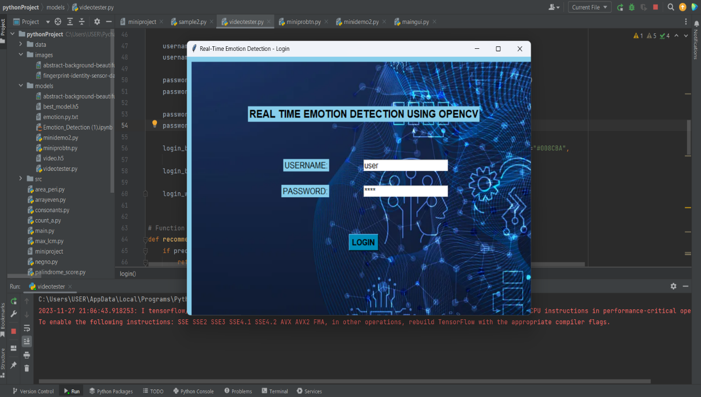

**5.4 OUTPUT DESIGN**

A quality output is one, which meets the requirements of the end user and presents the information clearly. In any system results of processing are communicated to the users and to other system through outputs. In output design it is determined how the information is to be displaced for immediate need and also the hard copy output. It is the most important and direct source information to the user. Efficient and intelligent output design improves the system’s relationship to help user decision-making.

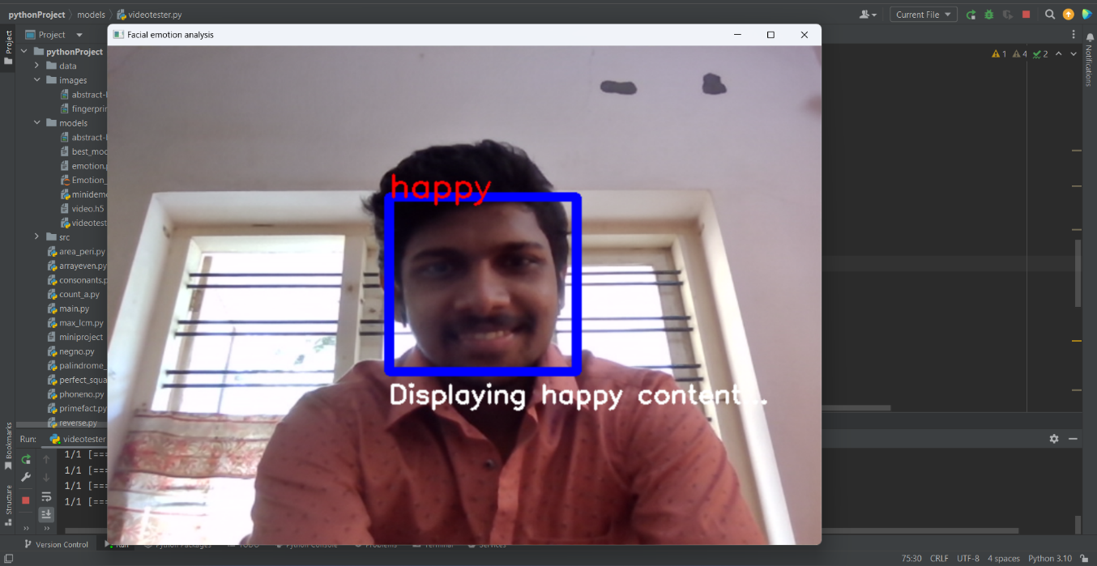

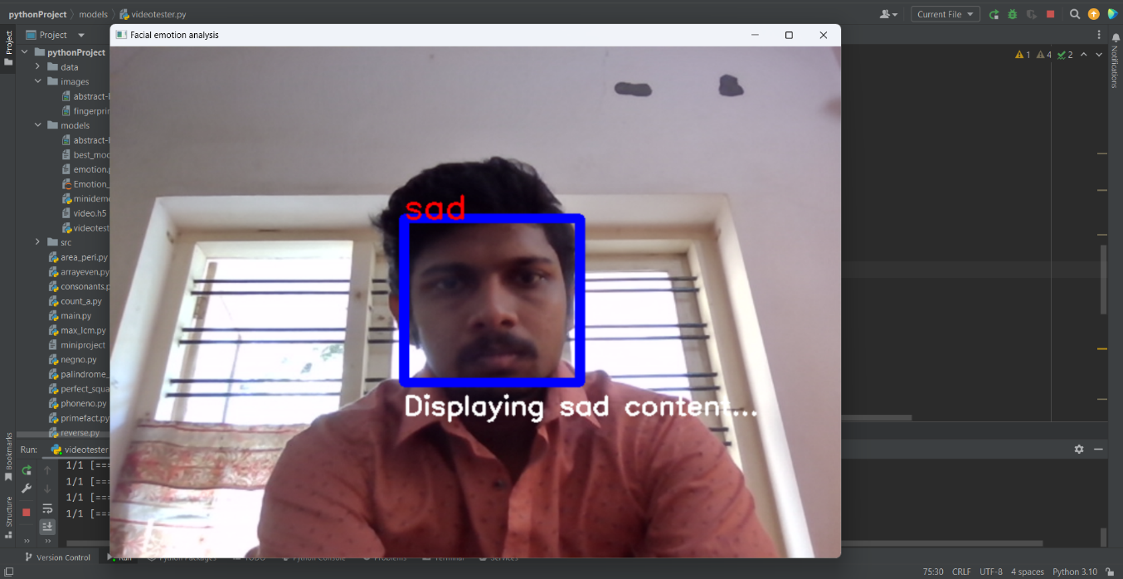

**5.5**

**PROGRAM DESIGN**

STOP DETECTION

REAL TIME EMOTION DETECTION USING OPENCV WITH CONTENT RECOMMENDATION

USER

USER LOGIN

EMOTION DETECTION

VIEW EMOTION

RECOMMEND CONTENTS

**CHAPTER 6**

**FUNCTIONAL AND NON FUNCTIONAL REQUIREMENTS**

**6.1 FUNCTIONAL REQUIREMENTS**

This project involves creating an application that uses facial recognition technology to detect emotions in real-time. The system captures the user's facial expressions through a webcam, recognizes emotions (such as happiness, sadness, anger), and then recommends content or motivational quotes based on the detected emotions. The user interacts with this system through a user-friendly interface where they can log in, and as the system recognizes their emotions, it provides relevant content or quotes accordingly. The application aims to offer personalized experiences based on the user's emotional state, creating a dynamic and engaging interaction between the user and the technology.

**6.2 NON-FUNCTIONAL REQUIREMENTS**

In systems, a non-functional requirement (NFR) is a requirement that specifies criteria that can be used to judge the operation of a system, rather than specific behaviors. They are contrasted with functional requirements that define specific behavior or functions.

* **Performance:** The system should have minimal latency in detecting emotions to provide a real-time experience. It should handle multiple user sessions simultaneously without significant degradation in performance.
* **Accuracy:** The facial emotion recognition should be highly accurate across diverse demographics, lighting conditions, and facial orientations.
* **User Interface:** The user interface should be intuitive and user-friendly, providing clear instructions and feedback.
* **Security:** Ensure data privacy and security by implementing measures to protect the user's facial data and login credentials.
* **Scalability:** The system should be scalable to accommodate increasing user loads and potential future updates or expansions.
* **Reliability:** The system should be reliable, minimizing crashes or system failures during operation.
* **Compatibility:** Ensure compatibility with various devices, web browsers, and operating systems as per the specified requirements (e.g., Windows 7 or higher, Internet Explorer, Chrome, Safari, and Opera).
* **Maintainability:** The codebase should be well-structured and documented for ease of maintenance and future enhancements.
* **Resource Utilization:** Optimize resource utilization (CPU, memory) to ensure efficient performance without overloading system resources.
* **Accessibility:** Ensure the application is accessible to users with disabilities, adhering to accessibility standards and guidelines.

**CHAPTER 7**

**TESTING**

**7.1 TESTING STRATEGIES**

Testing is the process of detecting errors. Testing performs a very critical role for quality assurance and for ensuring the reliability of software. The results of testing are used later on during maintenance also. The aim of testing is often to demonstrate that a program works by showing that it has no errors. The basic purpose of testing phase is to detect the errors that may be present in the program. Hence one should not start testing with the intent of showing that a program works, but the intent should be to show that a program doesn’t work. Testing is the process of executing a program with the intent of finding errors.

**7.2 UNIT TESTING**

Unit testing focuses verification effort on the smallest unit of software i.e., the module. Using the detailed design and the process specifications testing is done to uncover errors within the boundary of the module. All modules must be successful in the unit test before the start of the integration testing begins. In this project each service can be thought of a module. There are 3 modules like Admin, User, and Vendor. Giving different sets of inputs has tested each module. When developing the module as well as finishing the development so that each module works without any error. The inputs are validated when accepting from the user. In this website developer tests the programs up as system. Software units in a system are the modules and routines that are assembled and integrated to form a specific function. Unit testing is first done on modules, independent of one another to locate errors. This enables to detect errors. Through these errors resulting from interaction between modules initially avoided.

**Black Box Testing:** In the black box testing, test cases are designed from the examination of the input/output values only and no knowledge of design or code is required. The main approaches are:

* Equivalent class partitioning
* Boundary value analysis

**White Box Testing**: White box testing is an important type of unit testing. A large number of white box testing strategies exist. White box testing strategies are:

* Fault based testing
* Coverage Based testing

Fault based testing strategy targets to detect certain type of faults. This faults that a test strategy focuses on constitutes the fault model of the strategy. Coverage based testing strategy attempts to execute (or cover) certain elements of program.

**7.3 INTEGRATION TESTING**

**Types of test cases:**

**Integration test case:** Here we execute test cases which just tell about the connectivity from one module to other module and integrating one application to other application and how the application moves from parent node to child no demand vice versa

**Functional Test case**: Here we execute test cases which tell about the functionality of the application and talks about the desired output to be seen. Internally we have different type of test cases when we write here like range, output values, BVA, ECP and so on. We give input and expect some output according to the SRS. Here we check individual module completely by checking each and every tab, text box, and buttons and so on.

**Non-Functional Test case:** Test cases related to user friendliness like font, image, colour, how easy to navigate etc., performance related, security related comes under here.

**User Acceptance test case:** These test cases are crucial and very important to client-side people, because these test case talks about these business and approach of the application to complete a particular client task, which is also called as End-End Business scenario test case. Here we won’t be doing testing related to UI, Functional or Non-Functional, we talk about business and scenario which the application is made for.

**7.4 SYSTEM TESTING**

Here the entire software system is tested. The reference document for this process is the requirements document, and the goal is to see if software meets its requirements. Here the entire software has been tested against requirements of project and it is checked whether all requirements of project have been satisfied or not.

**Alpha Test:** The first test of newly developed, when the first round of bugs has been fixed, the product goes with actual users for testing. For custom software the customer may be invited into the vendor's facilities for an alpha test to ensure the client's vision has been interpreted properly by the developer. It occurs before the product is released, the white box view can provide additional insights to spot problems or troubleshoot bugs uncovered during the testing. Developers will typically immediately address issues discovered during alpha testing and update the test environment with fixes as soon as possible for additional testing.

**Beta Test:** A test of new or revised software application that is performed by users at their facilities under normal operating conditions. Beta testing follows alpha testing. Vendors of packaged software often offer their customers the opportunity of beta testing new releases or versions and the beta testing

of elaborate products such as operating systems can take months. It is a type of user acceptance testing where the product team gives a nearly finished product to a group of target users to evaluate product performance in the real world.

**7.5 TESTING RESULT**

In testing the emotion detection project, several significant observations and results emerged:

* **Usability and User Experience:** Assessing the ease of navigation, clarity of instructions, and overall user satisfaction while interacting with the system.
* **Performance Metrics:** Measuring the system's response time, processing speed, and resource utilization under different conditions, ensuring it meets the defined performance benchmarks.
* **Scalability and Future Expansion:** Evaluating the system's ability to handle increased user loads and data volume, and its readiness for future upgrades or feature additions.
* **Reliability and Fault Tolerance:** Testing the system's resilience against errors, interruptions, or unexpected inputs to ensure consistent and reliable operation.
* **Compliance and Compatibility:** Verifying adherence to industry standards, regulatory compliance, and compatibility with various hardware and software configurations.
* **Documentation and Maintenance:** Reviewing the comprehensiveness of system documentation, including user manuals and technical guides, to support ongoing maintenance and updates.
* **Feedback and Improvement:** Collecting user feedback and suggestions to incorporate improvements, address concerns, and refine the system's performance and functionality.
* **Security and Data Integrity:** Evaluating the effectiveness of security measures in safeguarding sensitive user data and ensuring the integrity of information transmitted and stored.

**CHAPTER 8**

**RESULTS AND DISCUSSION**

* 1. **RESULTS(SALIENT FEATURES)**

Some of the salient features of a real-time emotion detection using OpenCV with content recommendation project:

**Real-time Emotion Detection:**

* Utilizes OpenCV for real-time face detection from a webcam or video file.
* Employs a pre-trained emotion recognition model to extract emotion information from detected faces.
* Provides real-time feedback on the user's emotional state.
* Can be used to monitor emotions in various settings, such as education, healthcare, and customer service.

**Content Recommendation:**

* Recommends appropriate content based on the detected emotion.
* Considers factors like genre, mood, and sentiment when recommending content.
* Provides personalized content recommendations that cater to the user's current emotional state.
* Can be used to enhance user experience and engagement.

**User-Friendly Interface:**

* Displays detected emotion and recommended content in a clear and concise manner.
* Provides easy navigation and interaction for users.
* Enhances the overall user experience and accessibility of the system.

**Real-time Processing:**

* Optimizes code for real-time performance to ensure smooth and efficient emotion detection and content recommendation.
* Minimizes latency and delays in processing and displaying results.
* Enables seamless user interaction and responsiveness.

**Data Pre-processing and Augmentation:**

* Employs proper data pre-processing techniques to improve the performance of the emotion recognition model.
* Handles noise reduction, image normalization, and data augmentation effectively.
* Enhances the robustness and generalizability of the model across different datasets.

**Ethical Considerations:**

* Prioritizes user privacy and data protection.
* Maintains transparency in data collection and usage practices.
* Addresses potential biases in emotion detection and content recommendation algorithms.
* Ensures responsible and ethical implementation of the system.
  1. **SCREENSHOTS**

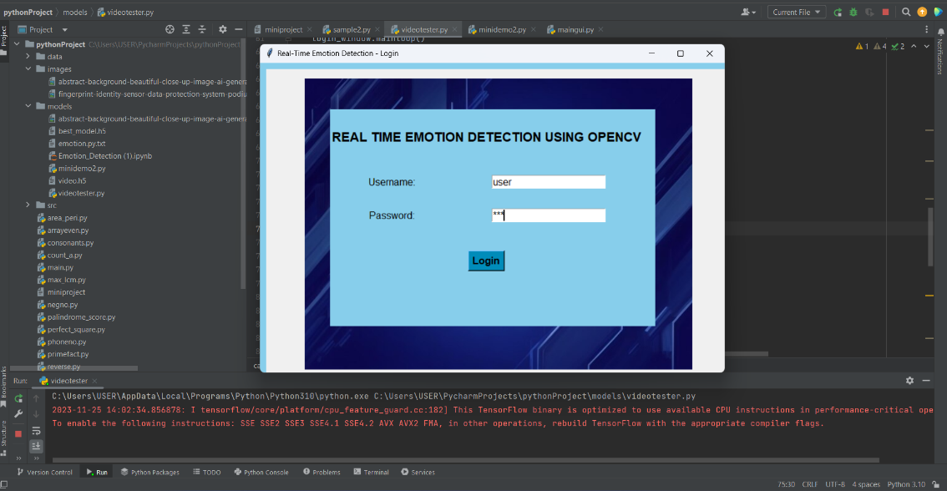

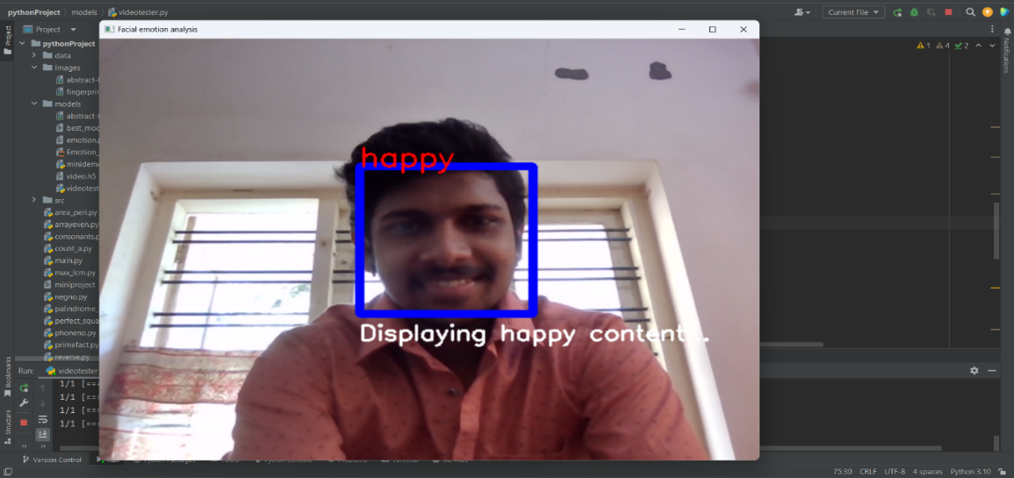

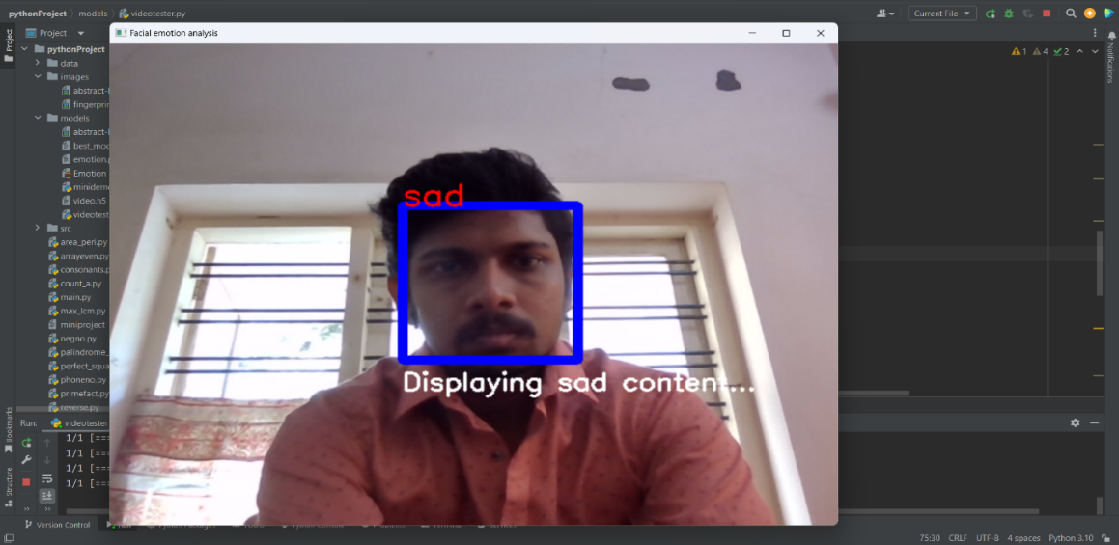

**CHAPTER 9**

**CONCLUSION**

* 1. **SYSTEM IMPLEMENTATION**

The system implementation of a real-time emotion detection using OpenCV with content recommendation project can be divided into the following main stages:

**Data Acquisition and Preprocessing:**

* Collect a dataset of facial images with corresponding emotion labels.
* Preprocess the images to ensure consistency in size, format, and quality.
* Augment the dataset to improve the model's generalizability.

**Emotion Recognition Model Training:**

* Choose an appropriate emotion recognition model architecture, such as CNN or RNN.
* Train the model on the preprocessed dataset using appropriate loss functions and optimizers.
* Evaluate the trained model's performance on a separate validation dataset.

**Content Recommendation Algorithm Development:**

* Design a content recommendation algorithm that considers factors like emotion, genre, mood, and sentiment.
* Implement the algorithm using appropriate data structures and programming techniques.
* Evaluate the effectiveness of the algorithm in recommending relevant content based on emotions.

**System Integration and User Interface Design:**

* Integrate the emotion recognition model and content recommendation algorithm into a real-time system.
* Design a user-friendly interface that displays detected emotions and recommended content.
* Ensure smooth interaction and responsiveness for users.

**Real-time Processing Optimization:**

* Optimize code for real-time performance to minimize latency and delays.
* Utilize hardware acceleration techniques, if available, for improved efficiency.
* Ensure the system can handle real-time processing demands effectively.

**Testing and Evaluation:**

* Thoroughly test the system using a variety of scenarios and input data.
* Evaluate the system's performance in terms of emotion detection accuracy, content recommendation relevance, and overall user experience.

**Deployment and Maintenance:**

* Deploy the system to the desired platform, such as a web application or mobile app.
* Monitor the system's performance in real-time and address any issues promptly.
  1. **CONCLUSION**

Real-time emotion detection using OpenCV with content recommendation is a promising project with the potential to revolutionize various aspects of human-computer interaction. By leveraging the power of facial emotion recognition and content recommendation algorithms, this project can create more personalized and engaging experiences for users. The project's ability to detect and respond to users' emotional states in real-time opens up a plethora of applications in diverse fields, such as education, healthcare, entertainment, and customer service. In education, it can tailor learning content and adapt teaching methods to match students' emotional states and enhance their learning experience. In healthcare, it can monitor patients' emotional well-being, detect signs of stress or anxiety, and provide personalized interventions. In entertainment, it can recommend content that aligns with users' current mood, preferences, and emotional state. And in customer service, it can analyze customer interactions, identify potential issues, and provide personalized support tailored to their emotional needs. The project's potential impact is far-reaching, as it can empower individuals to better understand and manage their emotions, enhance communication and engagement in various settings, and pave the way for more personalized and adaptive technologies. As the field of emotion recognition and artificial intelligence continues to advance, the impact of this project is poised to grow even further. The Emotion Detection and Content Recommendation system leverage advanced technologies to interpret facial expressions and recommend personalized content based on detected emotions. This innovative solution aims to enhance user experience by delivering tailored suggestions aligned with their mood. With its robust backend built on sophisticated algorithms and machine learning models, coupled with an intuitive frontend, the system offers a seamless interface for users. By prioritizing accuracy, user privacy, and continual improvement, this project represents a promising intersection of emotion analysis and personalized content delivery, poised to redefine user interaction in the digital landscape.

* 1. **FUTURE ENHANCEMENT**

Some potential future enhancements for a real-time emotion detection using OpenCV with content recommendation project:

**Multimodal Emotion Recognition:**

* Integrate additional modalities beyond facial expressions, such as speech, text, and physiological signals, to provide a more comprehensive understanding of user emotions.
* Utilize multimodal fusion techniques to combine information from different modalities for more accurate and robust emotion recognition.

**Context-Aware Content Recommendation:**

* Incorporate contextual factors, such as time of day, location, and social context, into the content recommendation algorithm to provide more personalized and relevant recommendations.
* Develop context-aware recommendation models that adapt to different scenarios and user preferences.

**Explainable AI and Transparency:**

* Implement explainable AI techniques to provide insights into the decision-making process of the emotion recognition and content recommendation models.
* Enhance transparency and user understanding of the system's recommendations.

**Real-time Feedback Mechanisms:**

* Implementing feedback loops for users to rate recommended content based on how well it matched their perceived emotions, enabling the system to refine recommendations further.

**Cross-platform Integration:**

* Extending the system's capabilities across various devices and platforms to ensure a consistent and seamless experience for users, whether on desktop, mobile, or other connected devices.

**BIBLIOGRAPHY**

1. **BOOKS:**

* Programming Python: Powerful Object-Oriented Programming: Mark Lutz
* Python Machine Learning: Sebastian Raschka
* Machine Learning For Absolute Beginners: Oliver Theobald

1. **WEBSITES:**

* <https://www.kaggle.com/>
* <https://chat.openai.com/>

1. **JOURNAL AND PUBLICATIONS**

* Robust real-time emotion detection system using CNN architecture: Shruti Jaiswal & G. C. Nandi in 2020
* Real-Time Prediction of Car Driver’s Emotions using Facial Expression: Pawan Wawage* and Yogesh Deshpande in 2022.